**SPRINT 2**

In sprint 2 a dashboard was created from where different features were accessed. View profile and Feedback form were created.

The below image is dashboard after successful login:

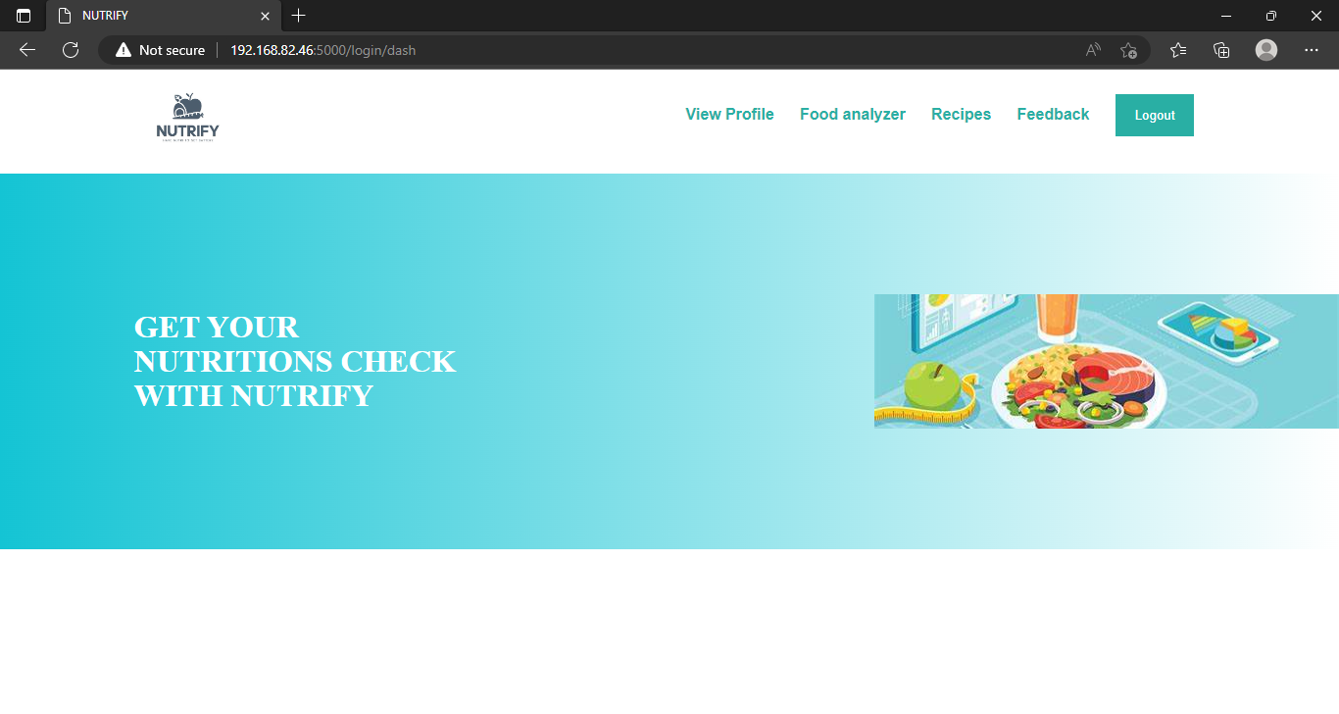

The user can view their profile

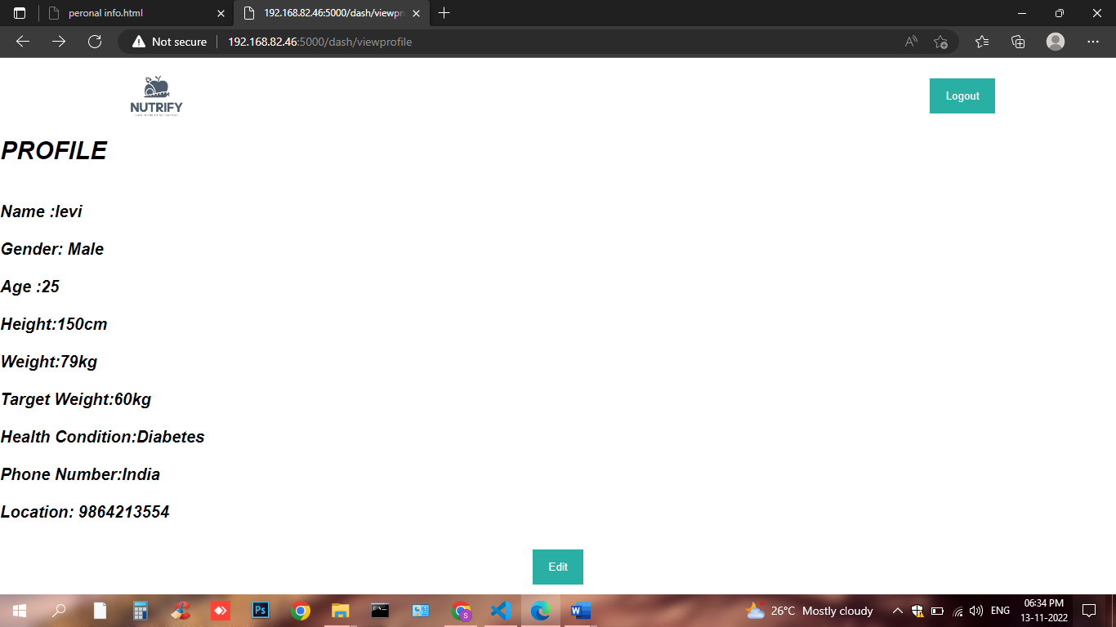

And user can fill their form:

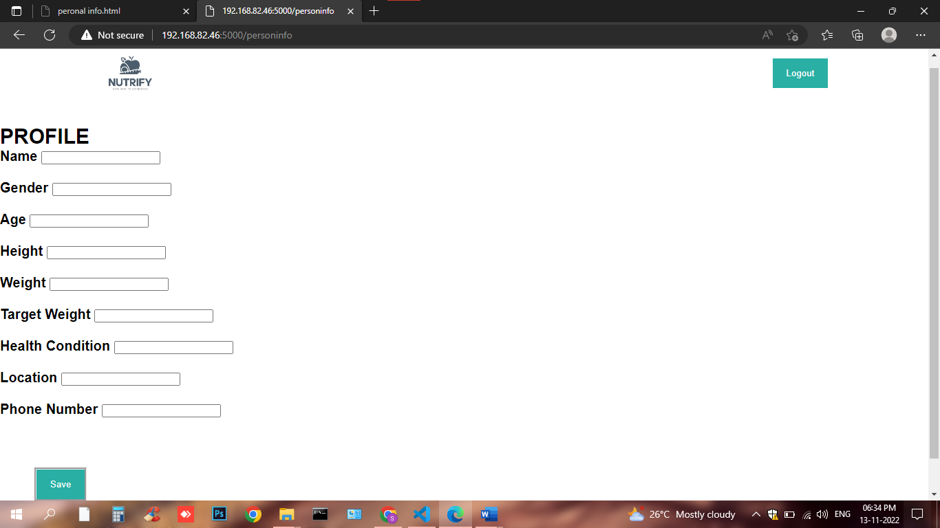

It have also feedback form for users to post query which is stored in respective database

